**NOTE: This is an official document by Indexademics. Unless otherwise stated, this document may not be accredited to individuals or groups other than the club IDX, nor should this document be distributed, sold, or modified for personal use in any way.**

**IDX G9 Chemistry S+ STUDY GUIDE ISSUE 5**

**By Winson and Kelvin**

**7.2 Effective Nuclear Charge ($Z_{eff}$)**

Key Concepts:

* Definition: The net positive charge experienced by valence electrons, accounting for nuclear charge and shielding b y inner electrons.
* Shielding Effect: Inner electrons reduce the attraction between valence electrons and the nucleus.
* Trends: $Z_{eff}$ increases over across a period and slightly increases down a group.

**7.3 Sizes of Atoms and Ions**

Atomic Radius:

* Trends:
  + Across a period: Decreases
  + Down a group: Increases

Ionic Radius:

* Cations: Smaller than parent atoms (loss of electrons reduces repulsion).
* Anions: Larger than parent atoms (gain of electrons increases repulsion).
* Isoelectronic Series: Size decreases with increasing nuclear charge

Example:

Largest atom in Na, Be, Mg: **Na** (Group 1, Period 3).

**7.4 Ionization Energy (IE)**

Definition: Energy required to remove an electron from a gaseous atom.

* 1st IE: Energy to remove the first electron.
* 2nd IE: Energy to remove the second electron (higher than 1st IE).

Trends:

* Across a period: Increases
* Down a group: Decreases

Exceptions:

* Between Groups IIA and IIIA (e.g., Be > B): Removing a p-electron (higher energy) vs. s-electron.
* Between Groups VA and VIA (e.g., N > O): Electron pairing in orbitals increases repulsion.

#### ****7.5 Electron Affinity (EA) & Electronegativity (EN)****

Electron Affinity:

* Energy change when an electron is added to a gaseous atom.
* Trend: Becomes more exothermic (negative) across a period.

Electronegativity:

* Definition: Ability of an atom to attract electrons in a bond.
* Trends:
  + Across a period: Increases (higher $Z_{eff}$).
  + Down a group: Decreases (valence electrons farther from nucleus).
* Scale: Fluorine (F) = 3.98 (highest); Francium (Fr) = 0.7 (lowest).

Example: Most electronegative in Cl, Se, Br: **Cl** (Group 7A, Period 3).

Chapter 8: Chemical Bonding

8.1 Lewis Symbols and the octet rule

Definitions:

Chemical bond is the electrostatic attraction force that holds two atoms together.

Ionic bond: attraction between cations and anions

Covalent bond: attraction between nucleus and shared electrons

Metallic bond: attraction between metal cations and delocalized electrons

Octet rule: tendency for electrons to achieve noble gas configuration (octet refers to ‘8’ valence electrons)

Lewis symbols is an drawing method alternative for electron configuration. It is used to express chemical bonding, molecular geometry, and demonstrate valence.

For drawing lewis structures:

1. Write the element(eg. H)
2. Determine the number of valence electrons(eg. H has 1)
3. draw 1 dot for 1 valence electron(for H, since only 1 valence, only need to draw 1)
4. for most cases (exceptions are not considered in the test), valence electrons should be as spread out on the four sides of the letter as possible (hunds rule)

Table for lewis symbols:

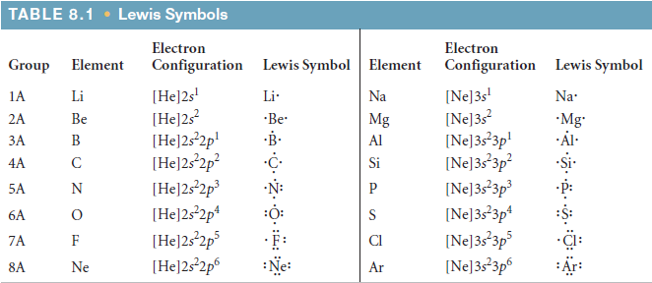

8.2 Ionic Bonding

Because of the octet rule, atoms want to gain/lose electrons to form noble gas configuration

Losing electrons == cation (+)

Gaining electrons == anion (-)

Eg: for Halogens (group 17), because they have 7 valence and need 1 more to achieve valence, they often appear as anions (1-)

Tip for the test: Check the periodic table before you do bonding questions !

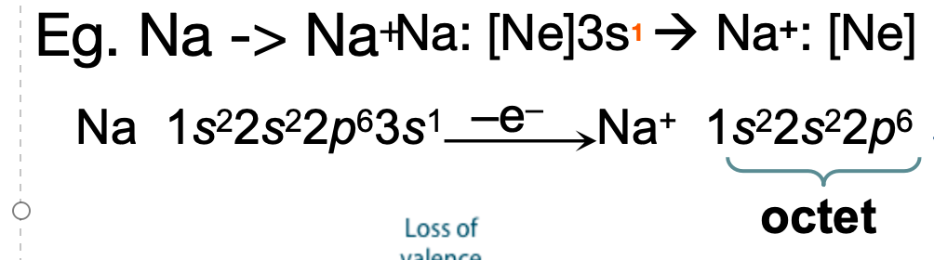

PPT slide demonstrating how cations form

For elements from group 1B through 4A in periods 4 through 6, they form the ions by forming a pseudo-noble gas notation which is relatively stable as well.

Eg. Zn, Pb, Ag,…

Ionic Compounds:

Ionic compounds can be described as simply the bond between cations and anions. The cations give electrons to the anions, creating an electrostatic force that bonds the two together.

Tip for the test: When asked to explain trends of ionic bonds, refer to the Coulomb’s Law

Ionic Compounds must be neutral(balance of charges in cations and anions).

The chemical formula of an ionic compound refers to a ratio known as a formula unit (the lowest whole-number ratio of ions in an ionic compound).

Ionic compounds exist in groups. When they are grouped together, the pattern is always +-+-+-..., making it look like a lattice, which we referr to as lattice structures.

Properties of Ionic Compounds:

Ionic compound has a high melting point and hardness

Ionic compounds are brittle.

Solid ionic compounds do not conduct electricity but molten ionic compounds or aqueous solutions of ionic compounds do.

Critical thinking: Why do ionic compounds in aqueous solutions/molten state conduct electricity?

So, since we already know what lattice structures are, what is lattice energy then?

-lattice energy is the energy required to completely separate ions in 1 mole of solid ionic structure to its gaseous ions.

Critical thinking: How would lattice energy increase?

8.3 Covalent Bonds

Review: What is the definition of valence electrons?

Covalent bonds are where electrons are shared between elements for the sake that both of them can achieve octet.

It occurs when atoms have quite high electronegativities

Critical thinking: so what properties do elements involved in covalent bonds have?

Here are the different number of covalent bonds(general trends):

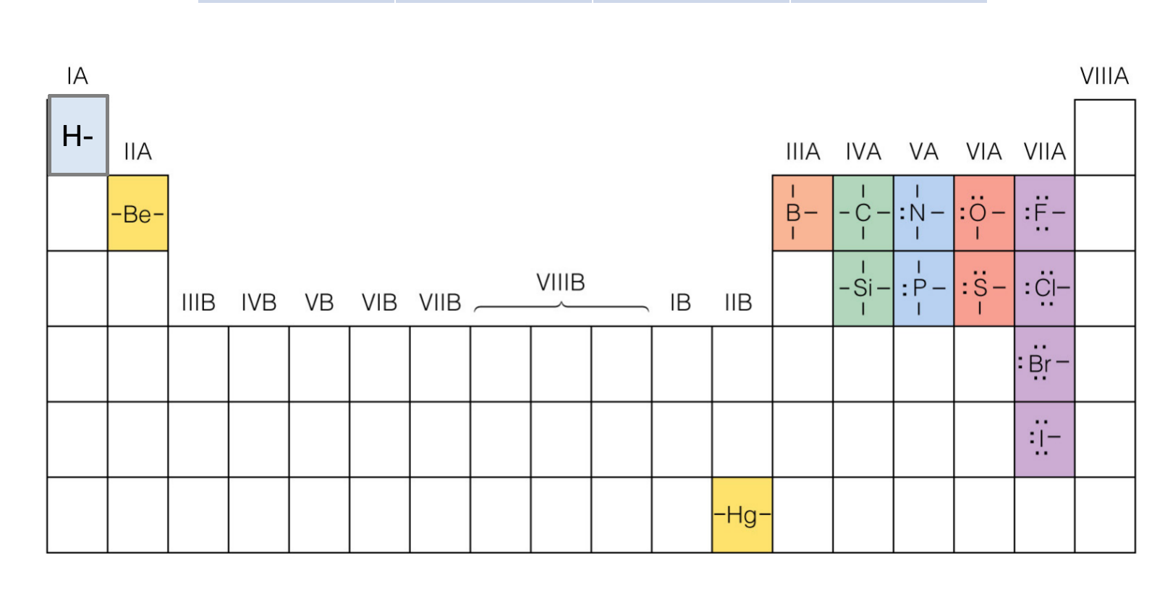

Critical Thinking: What conclusion can you draw from this trend?

Types of Bonds (by shape)

Sigma bonds and Pi bonds

Sigma bonds have overlap of electrons focused on the intermolecular axis.

The electron density is focused in the middle

Pi bonds only occur in p orbitals, and is where the p shells overlap vertically, forming two sausage-shaped clouds of electrons parallel to the intermolecular axis

Pi bonds have less energy because they have more repulsion

Covalent bonds can exist in double or triple bonds.  
Single bonds consist of 1 sigma

Double bonds consist of 1 sigma + 1 pi

Triple bonds consist of 1 sigma + 2 pi

8.4 Bond Polarity and Electronegativity

Bond polarity is a measure of how equally or unequally the electrons in any covalent bond are shared.

A nonpolar covalent bond is one in which the electrons are shared equally, as in Cl2 and N2.

In a polar covalent bond, one of the atoms exerts a

greater attraction for the bonding electrons than the other.

If the difference in relative ability to attract electrons is large enough, an ionic bond is formed.

Electronegativity:

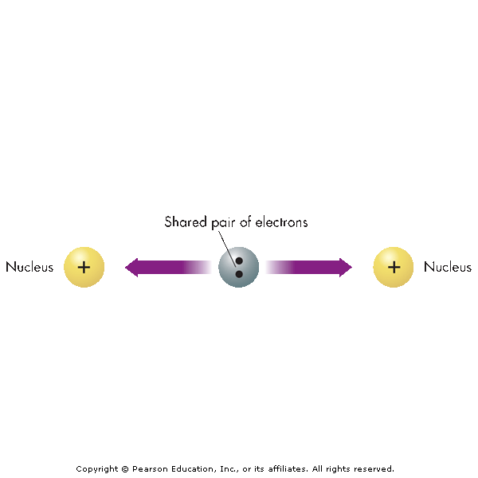

In general, electronegativity values decrease top to bottom，increase left to right.

Test tip: DONT explain questions through direct trends, instead focus on reasons behind the trends, which requires critical thinking

Polarity refers to a separation of positive and negative charge. In a nonpolar bond, the bonding electrons are shared equally (diatomic molecules, for example)

In a polar bond, electrons are shared unequally.

Can use electronegativity difference (pauling scale) to determine the type of bond:

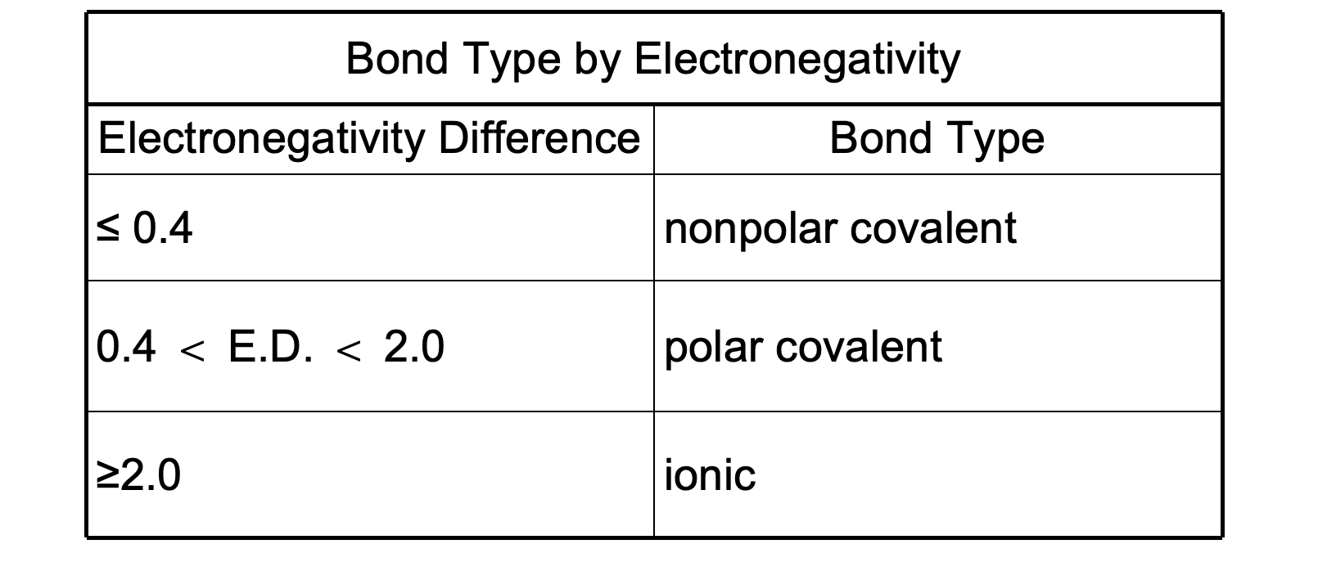

Dipole moments:

A positive to negative partial charge in an atom is measured as its dipole moment.

